2024 2nd International Conference on Networking and Communications (ICNWC)

Density Based Traffic Management System

Sugumaran S

*Department of ECE Vishnu Institute of Technology*

Bhimavaram, INDIA [sugumaran.s@vishnu.edu.in](mailto:sugumaran.s@vishnu.edu.in)

Nallamothu Rishitha

*Department of ECE Vishnu Institute of Technology*

Bhimavaram, INDIA [20PA1A04B0@vishnu.edu.in](mailto:20PA1A04B0@vishnu.edu.in)

Jayana Mounika Sowmya

*Department of ECE Vishnu Institute of Technology*

Bhimavaram, INDIA [20PA1A0459@vishnu.edu.in](mailto:20PA1A0459@vishnu.edu.in)

Matham Karthikeya Ganesh Siva Sagar

*Department of ECE Vishnu Institute of Technology*

Bhimavaram, INDIA [20PA1A0492@vishnu.edu.in](mailto:20PA1A0492@vishnu.edu.in)

Matireddy Venkata Siva

*Department of ECE Vishnu Institute of Technology*

Bhimavaram, INDIA [20PA1A0493@vishnu.edu.in](mailto:20PA1A0493@vishnu.edu.in)

Mogalla Ganesh

*Department of ECE Vishnu Institute of Technology*

Bhimavaram, INDIA [20PA1A0497@vishnu.edu.in](mailto:20PA1A0497@vishnu.edu.in)

***Abstract*— This work presents an innovative Density-Based Traffic Management System leveraging Arduino Mega and ultrasonic sensors for dynamic, real-time traffic flow optimization. The system integrates sensor technology with traffic infrastructure to enable efficient, adaptive traffic signal control. It consists of a microcontroller (Arduino Mega) and ultrasonic sensors, where the Arduino processes data from the sensors to monitor vehicle density on each lane. Based on the data collected, the system dynamically adjusts the green light duration for each lane, prioritizing lanes with higher vehicle density to reduce congestion and improve traffic flow. The data from the sensors is continuously monitored, allowing for real-time adjustments to the traffic signal timings, resulting in reduced wait times and optimized vehicle throughput. This system enhances traffic management efficiency, reduces fuel consumption, and improves overall road safety. The solution provides a cost-effective and scalable approach to modernizing urban traffic systems, contributing to the development of intelligent, adaptive traffic control for smart cities.**

***Keywords— IoT, Density-Based Traffic Management, Arduino Mega, Ultrasonic Sensors, Real-Time Traffic Control, Adaptive Traffic Signals, Vehicle Density Detection, Smart Traffic System, Traffic Flow Optimization, Dynamic Signal Timing, Intelligent Transportation System, Urban Traffic Management, Sensor-Based Control, Smart City Infrastructure, Embedded Systems, Traffic Congestion Reduction***

1. INTRODUCTION

Urbanization and rapid population growth have resulted in increased traffic congestion, which presents significant challenges for city infrastructure. Traditional traffic management systems, which typically operate on fixed-time or pre-programmed schedules, often fail to address real-time traffic conditions, leading to inefficiencies such as longer wait times, higher fuel consumption, and increased pollution. As traffic volume fluctuates throughout the day, these systems are unable to dynamically adapt, resulting in an imbalanced allocation of green time across lanes and intersections.

To address these issues, this paper presents a **Density-Based Traffic Management System** that leverages **Arduino Mega** and **ultrasonic sensors** to dynamically adjust traffic signal timings based on real-time vehicle density data. The proposed system collects traffic data from ultrasonic sensors installed on each lane to determine the number of vehicles present and predicts traffic density by measuring the distance between vehicles.

This information is then used to adjust the green light durations, prioritizing lanes with higher traffic density and ensuring optimized traffic flow across all lanes.

The core objective of this system is to improve the efficiency of traffic signal management by dynamically adjusting the signal timings based on real-time conditions. Unlike conventional fixed-timing systems, this approach reduces congestion, minimizes fuel consumption, and enhances overall road safety. The use of low-cost ultrasonic sensors and an Arduino-based control unit makes this system an affordable and scalable solution that can be easily deployed in existing traffic management frameworks.

The paper is organized as follows: Section 2 provides a review of related work on sensor-based and adaptive traffic control systems. Section 3 outlines the methodology and system design, detailing the hardware and software components. Section 4 presents the results from testing the system under various traffic conditions, and Section 5 discusses the findings and potential for future improvements. Finally, Section 6 concludes the paper and suggests directions for future research in intelligent transportation systems.

LITERATURE REVIEW

The integration of IoT into fuel station management brings forth a range of benefits, addressing challenges such as operational efficiency, safety, security, and customer experience. The existing body of literature on this subject reveals key insights into the development, implementation, and impact of these systems. A fuel level monitoring system is one such technology which can monitor the current level of the fuel on the go and give useful alerts as and when required has been proposed in [5]. In the contemporary landscape, petrol stations grapple with significant concerns regarding the unpredictable risk of explosions triggered by sudden external factors. Hence, an IoT technology is used [6] that would protect the petrol tank with a virtual vessel in case of dangerous events. An idea with new processes for fuel- saving, by installing a WSN operated with the Internet of Things (IoT) scheme has been developed in [7].

The proposed project emerges as a solution to address these issues, leveraging IoT and Cloud computing to enhance efficiency and provide cost-effective solutions for fuel station

2024 2nd International Conference on Networking and Communications (ICNWC) | 979-8-3503-6526-9/24/$31.00 ©2024 IEEE | DOI: 10.1109/ICNWC60771.2024.10537573

979-8-3503-6526-9/24/$31.00 ©2024 IEEE

management. In [8], the authors presented the design and implementation of a smart e-fuel station based on IoT and RFID. Using several indicators for fuel tank management, the goal of authors in [9] is to develop a fuel station. A monitoring tool for fuel tanks has been introduced in [10]. Additionally, several writers have examined how IoT can be integrated into a variety of innovative fields, such as security [11], management [12], alerting [13], and societal applications [14]. As a result, the main goal of this project is to use IoT capabilities to create a prototype that is especially made for automation of fuel station.

1. PROPOSED MODEL
2. *Block Diagram*

The Smart Traffic Management System consists of an Arduino Mega at the center, which controls traffic lights and manages data from ultrasonic sensors placed on four roads. Each road has two sensors to detect traffic density, which helps determine the duration for the green light (either 10 or 15 seconds). LED traffic lights (red, yellow, green) are used to manage vehicle flow, while TM1637 seven-segment displays show a countdown timer for the green light duration on each road. The microcontroller processes sensor inputs and updates the lights and displays accordingly, cycling through all four roads in sequence as shown in the Fig 1

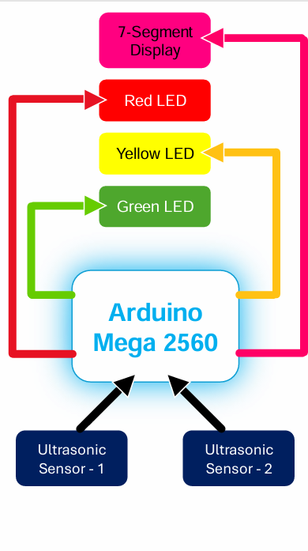

Fig. 1. Block diagram of proposed model.

1. *Implementation:  
   The circuit diagram features an Arduino Mega as the central controller, connected to eight ultrasonic sensors (two per road) to detect vehicle presence. Each road has three LEDs (red, yellow, green) controlling traffic signals, and four TM1637 seven-segment displays (one per road) showing the green light countdown timer. The sensors send data to the Arduino, which then controls the LEDs and updates the displays. All components are powered by a shared power supply as shown in the Fig 2.*

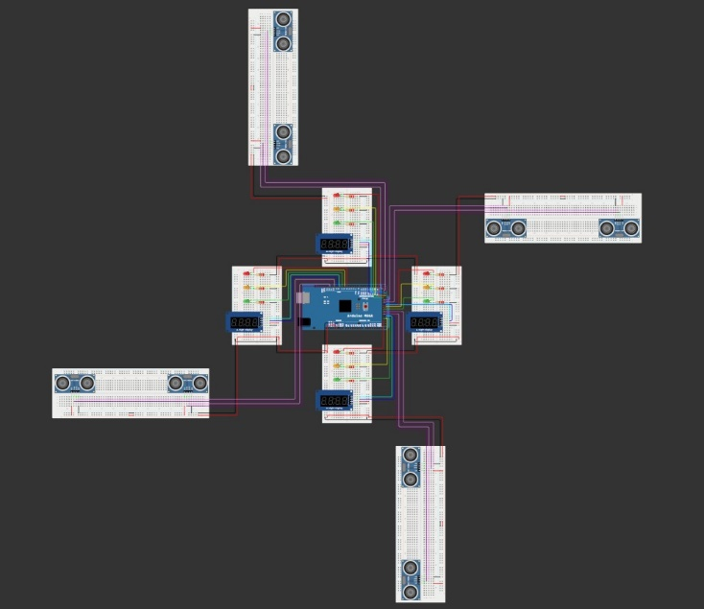

Fig. 2. Implementation model.

1. *Projected Hardware Model*

The developed hardware model for density based traffic management system has been depicted using Fig. 3.

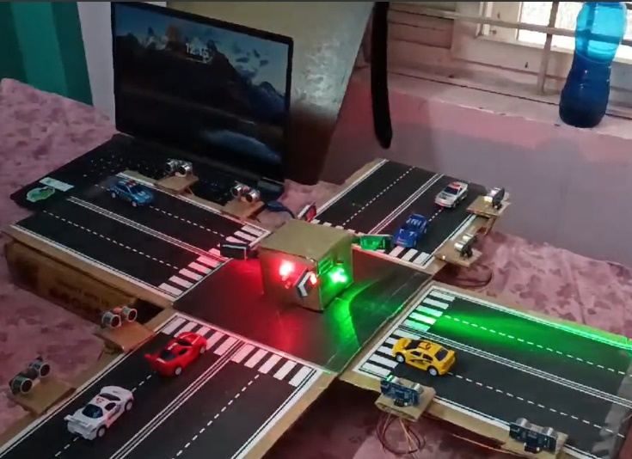

Fig. 3. Projected Prototype.

1. PROCEDURE

Flowchart Fig. 4, have been developed to help understand the operational concept of the proposed prototype.

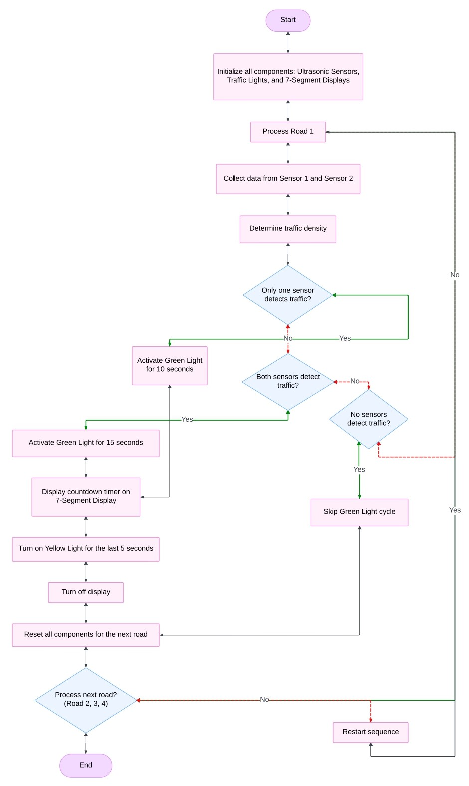 Fig. 4. Flowchart of proposed model.

1. EXPERIMENTAL RESULTS:

**Case 1: No Traffic (All the Roads)**

**Scenario:** No vehicles are detected by either sensors of the 4 road.

**Action:**

* Red light remains ON in ever road until the vehicle detects.
* Yellow and Green light remains OFF in ever road.
* 7-segment display remains OFF.

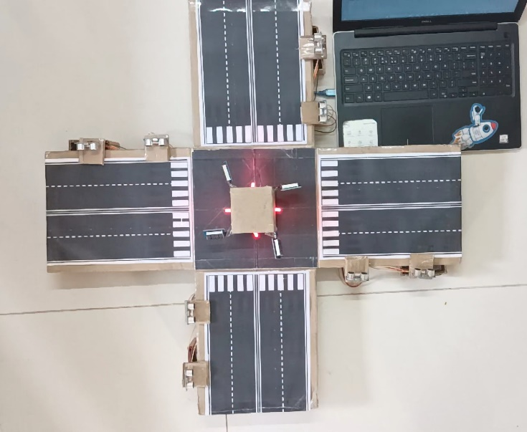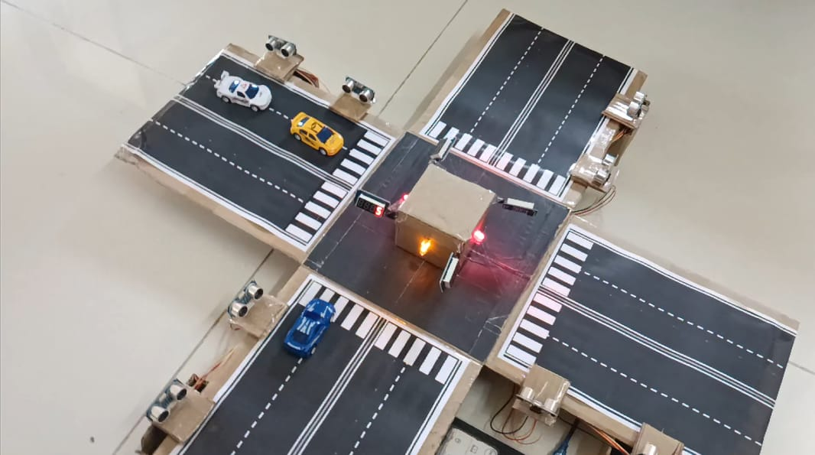

**Case 2: Low Traffic (Only Sensor 1 Active):**

**Scenario:** Vehicles are detected only by the first sensor of the road.

**Action:**

* Green light turns on for 10 seconds.
* Yellow light turns on for the final 5 seconds of the countdown.
* Red light activates after the green and yellow cycles.
* The timer is displayed on the 7-segment display during the green light.

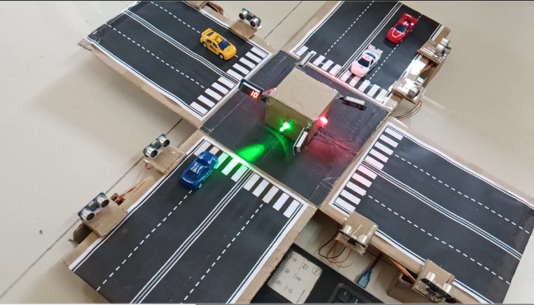

**Case 3: High Traffic (Both Sensors Active)**

**Scenario:** Vehicles are detected by both sensors of the road.

**Action:**

* Green light turns on for 15 seconds.
* Yellow light turns on for the final 5 seconds of the countdown.
* Red light activates after the green and yellow cycles.

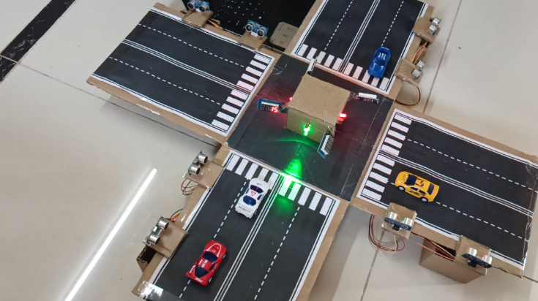

**Case 4: No Traffic (Skip Road)**

**Scenario:** No vehicles are detected by either sensor of the road.

**Action:**

* Skip the green and yellow light cycles.
* Red light remains ON.
* 7-segment display remains OFF.

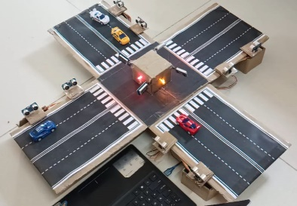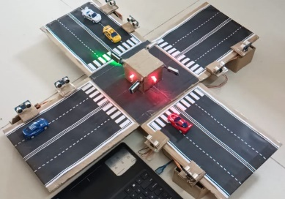

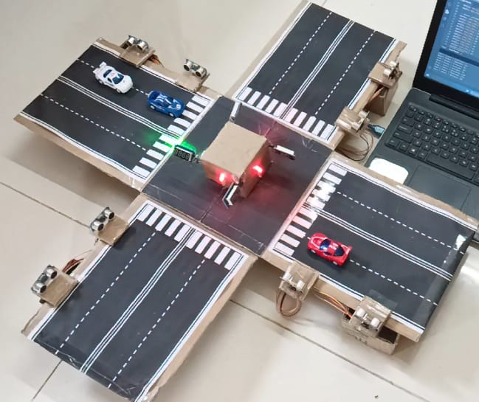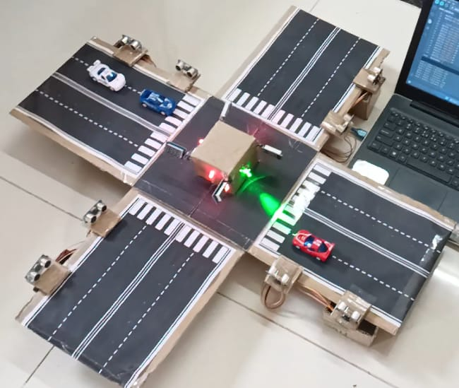

1. CONCLUSION

The density-based traffic management system developed in this project effectively addresses the challenges of traffic congestion by utilizing ultrasonic sensors and an Arduino microcontroller. Through real-time monitoring of vehicle density, the system intelligently manages traffic signals, enhancing road safety and improving the flow of vehicles. The successful implementation of this prototype demonstrates the potential of simple yet effective technological solutions in urban traffic management. Key achievements include:

* Accurate detection and measurement of vehicle density using ultrasonic sensors.
* Real-time control of traffic signals based on density data.
* A user-friendly interface with visual indicators (LEDs) for effective communication with drivers.

REFERENCE

1. 1.)F. Sultana, R. Bhardwaj, R. N. Kumar, R. Gaur, S. P. Shankar and A. Bharadwaj, "Smart Traffic Management System for Efficient Mobility and Emergency Response," 2024 International Conference on Knowledge Engineering and Communication Systems (ICKECS), Chikkaballapur, India, 2024, pp. 1-5, doi: 10.1109/ICKECS61492.2024.10616800. keywords: {Training;Adaptation models;Smart cities;Transportation;Emergency services;Data augmentation;Real-time systems;Smart Traffic Management;Urban traffic congestion;traffic management systems;real-time data;traffic flow optimization;Internet of Things (IoT);Artificial Intelligence (AI);emergency response mechanisms;peak hours;traffic efficiency},
2. B. E B, A. M, S. G, D. Jose and H. J. Magadum, "Intelligent Traffic Monitoring and Management System," 2023 International Conference on Computer, Electronics & Electrical Engineering & their Applications (IC2E3), Srinagar Garhwal, India, 2023, pp. 1-5, doi: 10.1109/IC2E357697.2023.10262689. keywords: {Wireless communication;Visualization;Adaptive systems;Smart cities;Software as a service;Traffic control;Synchronization;traffic signal monitoring;adaptive traffic control;traffic signal management;emergency/ green corridor},
3. 3).S. S. Hlaing, M. M. Tin, M. M. Khin, P. P. Wai and G. R. Sinha, "Big Traffic Data Analytics For Smart Urban Intelligent Traffic System Using Machine Learning Techniques," 2020 IEEE 9th Global Conference on Consumer Electronics (GCCE), Kobe, Japan, 2020, pp. 299-300, doi: 10.1109/GCCE50665.2020.9291790. keywords: {Smart cities;Roads;Machine learning;Telecommunication traffic;Fuels;Traffic congestion;Accidents;Smart city;machine learning;Big data analytics;intelligent Traffic;Mandalay},
4. 4.)S. S. R and L. Rajendran, "Real-Time Adaptive Traffic Control System For Smart Cities," 2021 International Conference on Computer Communication and Informatics (ICCCI), Coimbatore, India, 2021, pp. 1-6, doi: 10.1109/ICCCI50826.2021.9402597. keywords: {Adaptive systems;Image processing;Transportation;Traffic control;Software;Real-time systems;Hardware;Traffic monitoring;Traffic congestion detection;Traffic Management System;Intelligent Transportation System;OpenCV;Image Processing;ATCS;Adaptive traffic control system},
5. 5.)M. Amer and R. Maher, "PV/IoT based Smart Traffic Management System," 2022 International Conference on Electrical, Computer, Communications and Mechatronics Engineering (ICECCME), Maldives, Maldives, 2022, pp. 1-6, doi: 10.1109/ICECCME55909.2022.9988110. keywords: {Space vehicles;Processor scheduling;Roads;Urban areas;Traffic control;Real-time systems;Synchronization;Smart traffic management;Traffic congestion;IoT;Image processing;Fuel Consumption},
6. 6.)
7. V. Venkatesh, P. Raj, A. R and K. A. Reddy, "An intelligent traffic management system based on the Internet of Things for detecting rule violations," 2023 International Conference on Advances in Computing, Communication and Applied Informatics (ACCAI), Chennai, India, 2023, pp. 1-7, doi: 10.1109/ACCAI58221.2023.10199293. keywords: {Computational modeling;Object detection;Traffic control;Cameras;Regulation;Real-time systems;Object recognition;Internet of Things(IoT);Traffic management system;YOLOV3;Intelligent monitoring},
8. 7).S. Javaid, A. Sufian, S. Pervaiz and M. Tanveer, "Smart traffic management system using Internet of Things," 2018 20th International Conference on Advanced Communication Technology (ICACT), Chuncheon, Korea (South), 2018, pp. 393-398, doi: 10.23919/ICACT.2018.8323770. keywords: {Roads;Servers;Sensor systems;Cameras;Fires;Surveillance;Emergency Vehicle Management;Internet of Things (IoT);Smart Traffic Management System;Traffic Prediction;Traffic Signal Management},
9. 8.)A. Saikar, M. Parulekar, A. Badve, S. Thakkar and A. Deshmukh, "TrafficIntel: Smart traffic management for smart cities," 2017 International Conference on Emerging Trends & Innovation in ICT (ICEI), Pune, India, 2017, pp. 46-50, doi: 10.1109/ETIICT.2017.7977008. keywords: {Roads;Traffic congestion;Real-time systems;Servers;Junctions;Mobile communication;Vehicle dynamics;traffic conges
10. 9.)A. Hegde, O. Patil, S. Belurgikar and A. Godbole, "Street Smart: An Intelligent Traffic Management System," 2023 10th International Conference on Computing for Sustainable Global Development (INDIACom), New Delhi, India, 2023, pp. 649-654. keywords: {Wireless sensor networks;Costs;Roads;Urban areas;Process control;Traffic control;Infrared sensors;Traffic Management;Smart surveillance;Fuzzy Logic;YOLO;Convolutional Neural Networks;Deep Learning;Artificial Intelligence;Computer Vision;Image Processing},
11. 10)A. Jha, P. Agrawal, R. Kaur, A. Agrawal and M. Bhattacharya, "IoT Based Smart Traffic Controller System," 2023 Second International Conference on Informatics (ICI), Noida, India, 2023, pp. 1-5, doi: 10.1109/ICI60088.2023.10421439. keywords: {Road accidents;Sensor systems;Road safety;Servers;Monitoring;Intelligent sensors;Traffic congestion;IoT;Raspberry Pi;Sensors;Smart traffic controller;Roads;Safety},
12. 11.)K. D. S. A. Munasinghe, T. D. Waththegedara, I. R. Wickramasinghe, H. M. O. K. Herath and V. Logeeshan, "Smart Traffic Light Control System Based on Traffic Density and Emergency Vehicle Detection," 2022 Moratuwa Engineering Research Conference (MERCon), Moratuwa, Sri Lanka, 2022, pp. 1-6, doi: 10.1109/MERCon55799.2022.9906184. keywords: {Road accidents;Pandemics;Roads;Sociology;Transportation;Switches;Traffic control;YOLO;Object detection;OpenCV;Smart traffic control system},
13. 12.)U. M. Bashir et al., "A Review on Smart Traffic Management System," 2023 2nd International Conference on Multidisciplinary Engineering and Applied Science (ICMEAS), Abuja, Nigeria, 2023, pp. 1-6, doi: 10.1109/ICMEAS58693.2023.10429841. keywords: {Codes;Data acquisition;Urban areas;Road safety;Real-time systems;Internet of Things;Monitoring;Raspberry Pi Pico;MQTT;Traffic control;Daq dashboard and Ultrasonic Sensor},
14. 13.)S. Javaid, A. Sufian, S. Pervaiz and M. Tanveer, "Smart traffic management system using Internet of Things," 2018 20th International Conference on Advanced Communication Technology (ICACT), Chuncheon, Korea (South), 2018, pp. 1-1, doi: 10.23919/ICACT.2018.8323769. keywords: {Internet of Things;Roads;Software;Smart cities;Explosions;Web services;Traffic congestion;Emergency Vehicle Management;Internet of Things (IoT);Smart Traffic Management System;Traffic Prediction;Traffic Signal Management},
15. 14.)A. M. Miyim and M. A. Muhammed, "Smart Traffic Management System," 2019 15th International Conference on Electronics, Computer and Computation (ICECCO), Abuja, Nigeria, 2019, pp. 1-6, doi: 10.1109/ICECCO48375.2019.9043219. keywords: {Dashboard;Junction;Jam;V2I;Smart Traffic},
16. 15.)C. V. A. Satwik, L. P. Kumar, K. Vineeth and K. N. Pillai, "Intelligent Road Management System for Daily Transit," 2018 International Conference on Communication and Signal Processing (ICCSP), Chennai, India, 2018, pp. 0523-0526, doi: 10.1109/ICCSP.2018.8524314. keywords: {Roads;Sensors;Traffic congestion;Microcontrollers;Automobiles;Acoustics;Radio frequency;IoT;Microcontroller;Smart Poll System (SPS);Intelligent road management system for daily transit(IRMSDT)},